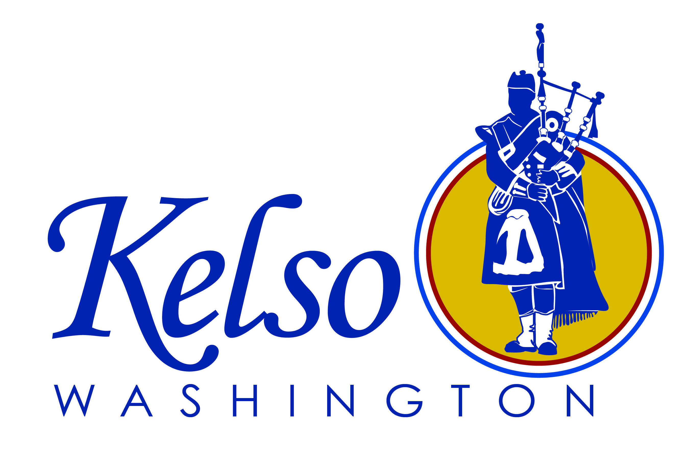 | Application  City of Kelso  Volunteers, Commissions,  Boards and Committees |  |  |  |  |  | Date Received  __________________
Personal Information
Last Name First Name Middle Initial

Address City/State Zip

Home Phone Message Phone Work Phone Email

Are you over the age of 18?  Yes No | Date of Birth |  | Do you have, or can you obtain a valid driver’s license?  Yes No Driver’s License Number:
Availability & Skills
Availability  Long Term Short Term Special Project |  |  |  | Are you currently certified in CPR? Yes No  First Aid? Yes No
Check the dates you can be available for work (check all that apply)
Sunday Monday Tuesday Wednesday Thursday Friday Saturday

In what particular areas of volunteer work, commission, board or committee are you interested?

Board of Adjustment and Appeals Lodging Tax Advisory Committee ’Big Idea’ Tourism Committee
Stormwater Advisory Committee Planning Commission Housing Authority
Civil Service Library Board Park Board
Highlander Festival Depot/Library/City Volunteer Other: _________________________

What general skills/experience/education would you like to share in your work for the City of Kelso?

Criminal Convictions
Have you ever been convicted of a felony or released from prison within the last ten (10) years, or a misdemeanor other than minor traffic offenses within the past three (3) years? (A conviction will not necessarily bar you from appointment)
Yes No If yes, please explain:

Medical Considerations
Do you have any medical, physical or emotional conditions that should be taken into consideration in arranging volunteer, commission, board or committee assignments?
Yes No If yes, please explain:

In case of emergency, please contact |  | Address/City/State/Zip |  |  |  |  |  | Phone
References (do not list relatives)
Name |  | Address/City/State/Zip |  |  |  | Phone
Notice to Volunteers
Persons appointed as volunteers, commission, board and committee members are not considered to be City of Kelso employees. Injury compensation, however, is provided through the Department of Labor & Industries. Services as a volunteer, commission, board or committee member are considered to be creditable work experience.

The data furnished on this form is furnished voluntarily and will be used to contact, interview and place volunteers and/or commission, board or committee members.

Signature is Required
To the best of my knowledge, the information herein is true and complete. I understand that falsification of this application is grounds for dismissal as a volunteer and/or commission, board, or committee member. Further, I give permission for an authorized representative of the City of Kelso to conduct a state patrol criminal background check in accordance with RCW 43.43.830-839 and to inquire of individuals about my ability to perform all aspects of the volunteer and/or commission, board or committee position for which I am being considered. I release the City of Kelso and those individuals/institutions that provide information from any liability that may arise from the provision of this information

As a volunteer, commission, board or committee member for the City of Kelso, I am fully aware that the work associated with being a volunteer, commission, board or committee member involves certain risks of physical injury or death. Being fully informed as to these risks and in consideration of my being allowed to participate in these City programs, I hereby assume all risk of injury, damage and harm to myself arising from such activities or use of City facilities. I also hereby individually and on behalf of my heirs, executors and assignees, release and hold harmless the City of Kelso, its officials, employees and agents, and waive any right of recovery that I might have to bring a claim or a lawsuit against them for any personal injury, death or other consequences occurring to me arising out of my volunteer, commission, board or committee member activities.

I give permission to have my photo taken and used for publicity purposes by the City. I authorize any necessary emergency medical treatment that might be required for me in the event of a physical injury and/or accident to me while participating in any of these programs/activities.

Signature |  |  |  |  | Date
If under 18, Parent or guardian’s signature |  |  |  |  | Date
Return completed and signed application to:
City of Kelso, City Manager’s Office
203 S. Pacific Ave
PO Box 819
Kelso, WA 98626

Please call 360-577-3301 if you have any questions or need additional information.

